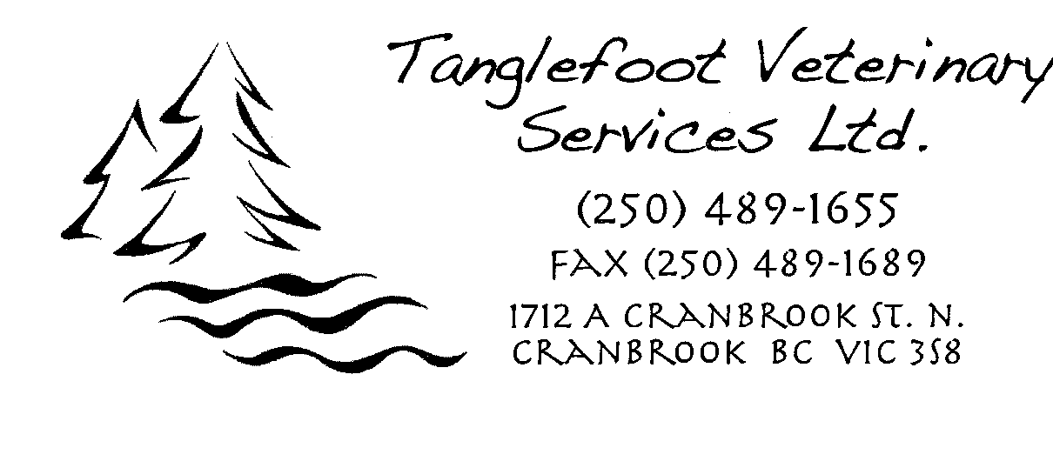

Dr. Uli Helvoigt

Dr. Joanna Kouwenberg

Dr. Denise Peebles

Dr. Stacy Radics

Healthy Pet Nutrition

**Goals of good nutrition**: Health and wellness, longer life, therapy for specific diseases.

Ingredients are the vehicles that house nutrients essential to healthy life. Animals need nutrients not specific ingredients. Nutrient needs vary according to age, activity/lifestyle, environment, health status, and reproductive status. Feed according to caloric needs. There is no value to ‘breed’ specific diets. Nutritional excesses are more common than and just as harmful as nutritional deficiencies. Pets are being overfed – obesity epidemic.

**How do you choose the best food for your pet?** **Pet Food Labels?**

**Ingredient List** – **Useless!** No information on the **quality** of the ingredients used. Very misleading.

**Guaranteed Analysis** – **Useless!** Very general idea of nutrients, no information on quality or digestibility.

**AAFCO Statement** – **Most useful** information on packaging.

Association of American Feed Control Officials sets standards for pet foods sold in USA – no regulations in Canada, but a number of pet foods sold in Canada will conform to AAFCO standards. Look for AAFCO statement on pet food packaging. Look for a **feeding trial** vs. formulated food (where food was formulated based on AAFCO nutritional guidelines, but never tested on animals for digestibility, palatability, performance or safety. Don’t let your pets do the feeding trial!). Look for which life stage the food was certified for (don’t feed senior pets a dog food designed for growth!). AAFCO does not regulate information appearing elsewhere – i.e. watch for misleading statements on websites, literature and signs. AAFCO does not require all pet foods to complete a feeding trial.

“The presence of a label guarantee that the food was tested using feeding trials provides the current best initial evidence that a diet is satisfactory.” Journal of the American Animal Hospital Association. Jan/Feb 2010, Vol. 46 – page 78.

What life stage is a food labelled for? Growth, adult, senior? Check AAFCO statement. AAFCO has no guidelines for seniors. Excess nutrients can be very harmful to senior pets. High quality companies do their own research. Find a company you can trust.

**Pet Food Myths:**

**Meat-first foods** – “There are no nutritional reasons that support providing excessive amounts of dietary protein. After the protein/amino acid requirements are met, additional protein provides no additional benefits. Thus, dog foods for adult maintenance should not exceed 30% DM (dry matter) protein. Cat foods for adult maintenance should not exceed 45% DM protein.” Small Animal Clinical Nutrition 5th Ed. Chapter 5, Macronutrients, page 95.

Nutrients can only be accurately compared on a dry matter basis but are often listed on a label ‘as fed’ to allow for meat (sometimes 80% moisture) to be listed first even though the primary component of the food is grain. Another label trick is to split ingredients – list several different forms of rice separately in a diet to allow meat to be listed first.

Healthy pets need a complete balance of nutrients from meat **and** non-meat sources (meat, vegetables, and grains). Dogs are omnivores. Excess protein is hard on kidneys.

**By-products** – **Not** always bad! Reputable food companies are only using more expensive, highly digestible by-product ingredients to **add** nutritional value. Some by-products contain **better** nutrients than less expensive meat meals. You **cannot** tell from a label what **qualities of ingredients** have been used – meat or meat by-product. You have to find a company you trust.

**Grain-free** – No nutritional foundation to support grain-free pet foods. Diets with grain are just as digestible as grain-free. Pets have a nutritional requirement for carbohydrates. Grain-free diets will simply use other sources, such as sweet potato which may contain even more carbohydrate and be less digestible.

**Corn** – An excellent all round nutrient. Reputable companies use ground and cooked corn to increase digestibility. Corn contains essential fatty acids, high quality protein, highly digestible carbohydrate, and antioxidants. It has better protein digestibility than rice or wheat. It is not a common allergen. It is **not a 'filler'** (means no nutritional value).

**Food allergies** – Adverse reactions to food affect less than 10% of dogs and cats.

**Be careful of misleading terms** – remember that AAFCO does not regulate any information that is not on packaging. Misleading terms are allowed on non-packaging marketing material (websites, brochures, signs...). Plus, products in Canada do not have to comply with AAFCO regulations.

* Organic – if 95-100% organic – gets USDA organic seal, 70% - can say made with organic, <70% - can only list organic ingredients on panel
* Natural – Not the same as organic. Means no chemical alterations except for added vitamins/minerals
* Holistic – No legal definition
* Human Grade – Statement not allowed (on packaging) unless food made in human approved food plant

**SummaryC:\Documents and Settings\ImagePilot\Local Settings\Temporary Internet Files\Content.IE5\YEFJXOV3\MC900438167[1].wmf**C:\Documents and Settings\ImagePilot\Local Settings\Temporary Internet Files\Content.IE5\ZL88DKT4\MC900438169[1].wmf

Ingredient list – **Useless** Guaranteed analysis – **Useless**

Examine the **AAFCO nutritional adequacy statement** on packaging – Look for a **feeding trial** and what**life stage** food has been tested for.

Find **a company you can trust** that has the research and data to prove they provide high quality ingredients, digestibility, palatability and safety.